**Java Full Stack**

* Build a fully functioning web application through a simplistic step from a professional trainer
* Java programming language
* Learn Java server pages, servlets, and JSTL from the basics to advance
* Understand building web forms with JSP
* Apply validations on the forms
* Use the web template to make the web application incredible
* Create-Deploy Servlets & Understand Servlet Lifecycle
* Learn how to Handle Session in JSP
* Develop Dynamic Web Applications
* Learn MVC in JSP
* Forms under JSP and Servlets
* Collection
* Learn the concept related to Generics
* Add validations on form data
* Adding records into the database
* Updating record(s) into database
* Deleting record(s) into database
* Spring Framework
* Web Services – RestFul API
* Spring Boot
* Spring Boot Restful API
* JavaScript

**Spring Framework**

* Inversion of control
* Spring Beans
* Resource-based URIs for CRUD methods
* JSON response
* HATEOAS - get links from resources
* Idempotence of HTTP Methods
* Method parameter and return type

**Spring Boot REST API**

* Spring Boot JWT token generator
* Integration of H2 database in Spring Boot
* Web template Integration
* Update Profile (Account) on the Spring Boot Blog
* Adding Spring security into the application
* Spring security login, adding rules and Bcrypt password
* Web App with spring boot
* Sending email for password reset
* Email Service in Spring Boot
* Docker and WSL on Windows
* Spring Boot OAuth2 JWT token generator
* Spring Boot OAuth2 JWT Adding Public-private KeyGenerator
* Spring boot JWT JPA Auth Controller
* Build Add Album API

**JavaScript basics**

* Keywords, datatypes in JavaScript
* Normal functions and expression functions in JavaScript
* Foreach methods
* JavaScript - Dom Object
* JavaScript - Callback functions

**React**

* Setting up React JS
* Material ui with React
* User management with react
* Making HTTP GET call with axios
* Local server, CORS and Proxy in React
* Login functionality
* Albums use case in React
* Token handling and local storage with react
* Dynamic menus and updated registration page
* Swagger implementation using React
* Upload photos onto the Albums
* Props, useEffect and Async
* Albums Show page
* Add, Edit, Delete functionality
* Show Photos using Albums API

Latesr Version of java is Java24

This course covering Java 17

**Nested class/Inner class:**

Class inside class. 2 types of nested class.

1. Static Nested class
2. Non-Static Nested class : Known as inner class, majorly due to the fact that instance inside instance.

There are again 3 types i.e. :

* Member inner class
* Local inner class
* Anonymous inner class

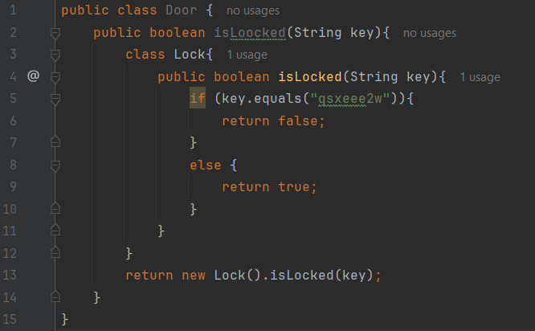

**Final keyword :**

It can be use with variable, method and class as well.

*Final Variable* – Once the values is initialized, it cannot be changed/update anywhere. We can initialize the value in constructors.

*Final Method* – Final methods cannot be override in child class or anywhere else in the project.

*Final Class* - If we mark a class as a fisnal then we cannot inherit the class.

**Maven :**

It is an Project managetment tool.Most popular use of maven is build management and dependencies

When we required some of JAR files (Hybernate, Spring, Commons Loggings, JSON) we can either manually download them from internet or we can use maven and let them know which all jar files are required.

Maven will go out and download the required jar files in projects and make those files available during compilr/run.